CertiTrust: AI-Powered Forensic Credential Verification Engine

AI23331 - FUNDAMENTALS OF MACHINE LEARNING MINIPROJECT REPORT
Submitted by
KUMARAN R (2116230701158)
MOKESH M (2116230701192)

in partial fulfillment for the award of the degree of
BACHELOR OF ENGINEERING
in

COMPUTER SCIENCE AND ENGINEERING


RAJALAKSHMI ENGINEERING COLLEGE ANNA UNIVERSITY, CHENNAI

MAY 2026

RAJALAKSHMI ENGINEERING COLLEGE, CHENNAI
BONAFIDE CERTIFICATE

Certified that this Project titled CertiTrust: AI-Powered Forensic Credential Verification Engine is the bonafide work of KUMARAN R (2116230701158), MOKESH M (2116230701192)” who carried out the work under my supervision. Certified further that to the best of my knowledge the work reported herein does not form part of any other thesis or dissertation on the basis of which a degree or award was conferred on an earlier occasion on this or any other candidate.

SIGNATURE

Dr. J. Jinu Sophia., M.E., Ph.D.,
Associate Professor
Department of Computer Science and Engineering,
Rajalakshmi Engineering College, Chennai-602 105.

Submitted to Mini Project Viva-Voce Examination held on

Internal Examiner External Examiner

ABSTRACT

"CertiTrust: The Ultimate AI-Powered Shield Against Credential Forgery in Digital Verification" is an advanced forensic system designed to revolutionize the document authentication process by minimizing fraud risk and enhancing institutional trust. By integrating state-of-the-art machine learning techniques such as Dual-AI Large Language Models (Gemini and Groq) and Forensic Regular Expressions, the system effectively analyzes complex certificate layouts beyond traditional OCR scanning. Key attributes evaluated include structural metadata integrity, EXIF header inconsistencies, font kerning anomalies, and qualitative heuristic trust scoring metrics. Leveraging these hybrid AI extraction methods significantly enhances detection accuracy and reliability in identifying potential forged credentials. This platform is developed as a robust full-stack web application using a modern architecture (React, TailwindCSS) synchronized with a dedicated Python FastAPI microservice for real-time risk assessment and cryptography. The system incorporates modern UI/UX principles to provide interactive analytics and transparent decision-making visualizations for verifiers. Security is rigorously enforced using SHA-256 cryptographic hashing and high-density QR seals to optimize the balance between instant accessibility and tamper mitigation. By providing a scalable, secure, and data-driven solution, "CertiTrust" aims to create a more resilient digital verification ecosystem. It addresses the challenges of sophisticated credential manipulation and manual auditing while ensuring the reputational security of educational institutions. This innovative approach offers a robust framework for academic administrators and employers to process submitted certificates with high confidence and efficiency, fostering a more secure and authentic professional environment.

ACKNOWLEDGMENT

Initially we thank the Almighty for being with us through every walk of our life and showering his blessings through the endeavor to put forth this report. Our sincere thanks to our Chairman Mr. S. MEGANATHAN, B.E, F.I.E., our Vice Chairman Mr. ABHAY SHANKAR MEGANATHAN, B.E., M.S., and our respected Chairperson Dr. (Mrs.) THANGAM MEGANATHAN, Ph.D., for providing us with the requisite infrastructure and sincere endeavoring in educating us in their premier institution.
Our sincere thanks to Dr. S.N. MURUGESAN, M.E., Ph.D., our beloved Principal for his kind support and facilities provided to complete our work in time. We express our sincere thanks to Dr. E. M. MALATHY, M.E., Ph.D., Professor and Head of the Department of Computer Science and Engineering for his guidance and encouragement throughout the project work. We convey our sincere and deepest gratitude to our internal guide Dr. J. JINU SOPHIA, M.E., Ph.D., Associate Professor Department of Computer Science and Engineering for her useful tips during our review to build our project.

KUMARAN R 2116230701158
MOKESH M 2116230701192

TABLE OF CONTENTS

CHAPTER PAGE NO.

ABSTRACT ii
ACKNOWLEDGEMENT iii
1. INTRODUCTION 01
1.1 General 01
1.2 Scope of the Work 02
1.3 Aim & Objectives of the Project 03
2. LITERATURE SURVEY 04
3. SYSTEM DESIGN 07
3.1 Architecture Diagram 07
3.2 Use Case Diagram 08
3.3 Hardware Specifications 09
3.4 Software Specifications 10
4. PROPOSED SYSTEM 12
5. MODULE DESCRIPTION 15
6. OUTPUT 18
7. CONCLUSION AND FUTURE ENHANCEMENTS 19
8. REFERENCES 21

CHAPTER 1

INTRODUCTION

1.1 General
In the contemporary digital landscape, the authenticity of academic and professional credentials has emerged as a critical challenge for educational institutions, corporate recruiters, and governmental bodies worldwide. The rapid proliferation of digital document formats has simultaneously lowered the barrier for sophisticated forgery and credential fraud. Certificates, which were once verified through labour-intensive manual processes involving physical inspection and telephone-based institutional confirmation, are now routinely submitted as digital files, making visual forgery undetectable to the human eye and trivially easy to produce with widely available image-editing tools.
CertiTrust is a highly sophisticated, machine learning-driven application engineered to provide instantaneous and forensically sound verification of academic and professional certificates. With the rapid digitization of academic records, credential forgery has become a pervasive issue with significant societal consequences, from under-qualified individuals occupying critical professional positions to the erosion of trust in institutional certification bodies. CertiTrust tackles this challenge by simulating and automating a complete, real-world forensic audit pipeline within a unified software system.
The system ingests document images or PDFs, processes them through deep neural networks to extract relevant metadata—including the recipient's Name, awarded Course, issuing Institution, and Final Score or Grade—and cross-verifies the extracted data against a comprehensive suite of established forensic patterns and historical records. At its architectural core, CertiTrust introduces a dynamic Trust Score that is derived from multiple heuristic and machine learning parameters, ensuring that the verification process is both fully transparent and highly accurate. Every decision the system makes is traceable and auditable, addressing a common criticism of opaque black-box AI systems in high-stakes applications.
Unlike conventional document management systems or simple OCR pipelines, CertiTrust treats every uploaded certificate as a potential forensic exhibit. It applies computer vision techniques to detect pixel-level anomalies, natural language processing to parse and validate extracted text, cryptographic mathematics to seal verified documents, and graph-theoretic machine learning to detect systemic and coordinated fraud patterns across an entire network of institutions and candidates. This multi-disciplinary approach, drawing from the core principles of the Foundations of Machine Learning, positions CertiTrust as a robust, future-proof solution to a problem that will only grow in significance as the world becomes increasingly reliant on digital credentials.

1.2 Scope of the Work
CertiTrust is scoped to deliver a complete, end-to-end credential verification platform that operates as a unified machine learning backend paired with an interactive, real-time frontend dashboard for the comprehensive management of certificate lifecycles. The system is specifically designed to simplify and automate the credential audit process by providing a centralized, intelligent platform that institutions, corporate verifiers, and individual candidates can interact with through a clean, intuitive interface. The scope of the work encompasses the following key functional domains:
- Ingestion and secure pre-processing of certificate files in both PDF and common image formats (JPEG, PNG, TIFF), including malicious metadata stripping and noise reduction.
- Deep learning-assisted Optical Character Recognition (OCR) combined with Large Language Model parsing to extract structured metadata from unstructured document images.
- Dynamic Trust Score calculation using a multi-parameter heuristic integrity check engine, evaluating structural, visual, and metadata-level document properties.
- Cryptographic hashing using the SHA-256 algorithm to provide mathematical immutability and instantaneous post-verification tamper detection.
- Generation of high-density, self-contained QR seals that encapsulate all verified metadata and provide a secure cryptographic link to the central database.
- A 'Quick Check' portal that provides instantaneous cross-verification of physical QR seals using standard mobile scanners, enabling offline and field verification.
- A Dual-AI Hybrid fallback system utilizing Google's Gemini and Groq's Llama LLMs to guarantee 100% system uptime and consistent extraction quality.
- A Graph-Enhanced Machine Learning (GEML) module for tracking institutional reputation scores and detecting coordinated forgery networks.
- zAn automated digital audit report generation engine that produces complete, downloadable verification reports for each processed credential.
The scope explicitly excludes the physical printing or notarization of certificates and any real-time communication with live institutional databases, as the system is designed as a self-contained forensic engine that operates on the document's intrinsic properties and the records within its own secured database.

1.3 Aim and Objectives of the Project
The primary aim of the CertiTrust project is to build a scalable, production-grade, machine learning-driven forensic engine that effectively bridges the gap between physical document verification and modern digital cryptography. The system aims to provide a mathematically verifiable, transparent, and highly automated alternative to manual credential verification, thereby drastically reducing instances of credential fraud in academic and professional settings. The specific technical objectives of the project are enumerated as follows:
- To develop an automated multi-stage extraction pipeline utilizing cutting-edge Large Language Models, specifically Google Gemini 1.5/2.0 Flash and Meta's Llama 3.3 via Groq Cloud, for high-accuracy, zero-hallucination metadata parsing from diverse certificate formats and layouts.
- To implement a fail-safe, cascading architecture that routes extraction tasks from the primary AI model to the secondary AI model, and finally to a tuned Forensic Regex engine, thereby preventing any single point of failure from interrupting the verification pipeline.
- To design and implement a Neural Trust Protocol that quantifies document integrity across multiple forensic dimensions—including compression noise analysis, EXIF metadata consistency, font consistency, and layout regularity—into a single, interpretable Trust Score on a scale of 0 to 100.
- To create a Graph-Enhanced Machine Learning (GEML) framework using graph-theoretic algorithms to model the relationship network between issuing institutions, student candidates, and verification frequencies, enabling the detection of systemic and coordinated forgery rings.
- To generate self-contained, tamper-proof digital audit reports and cryptographic QR seals that mathematically bind a physical document to its verified digital record in the CertiTrust database.
- To deliver a premium, glassmorphism-inspired frontend user interface built with React and TailwindCSS that provides an intuitive, secure, and visually sophisticated dashboard for all verification operations.
- To demonstrate the practical application of the Foundations of Machine Learning (FOML) in a real-world security context, bridging theoretical ML concepts with impactful engineering solutions.

CHAPTER 2

LITERATURE SURVEY

Research in the domain of digital credential verification has consistently highlighted the urgent and growing need to transition from manual, human-driven audit processes to automated, mathematically verifiable systems. The literature on this subject spans multiple intersecting disciplines, including computer vision, natural language processing, cryptography, graph theory, and applied machine learning. A comprehensive survey of the relevant literature reveals both the foundational techniques upon which CertiTrust is built and the significant gaps in existing systems that this project aims to address.
Early work in automated document verification focused primarily on rule-based Optical Character Recognition (OCR) systems. These systems, while functional for standardized, high-quality document scans, demonstrated significant brittleness when confronted with the diversity of real-world certificate layouts, varied font families, background watermarks, and image compression artefacts. Studies published in IEEE and arXiv repeatedly identify hallucination as a critical failure mode of naive OCR pipelines, where the system confidently produces incorrect text that bears superficial resemblance to the actual content. This is particularly dangerous in a credential verification context, where a misread grade or name can have profound consequences. The limitations of legacy OCR systems necessitate the integration of more sophisticated semantic understanding layers, which is the foundational motivation for employing Large Language Models in the CertiTrust extraction pipeline.
The application of Large Language Models to document understanding tasks represents one of the most significant recent advances in this field. Transformer-based architectures, including the BERT family, GPT variants, and more recently the Gemini and Llama model families, have demonstrated remarkable capability in understanding context, correcting OCR errors through semantic reasoning, and extracting structured information from unstructured text. Research on retrieval-augmented generation and document-grounded question answering shows that LLMs can reliably parse complex, multi-format documents when provided with appropriate prompting strategies. CertiTrust leverages this capability by designing a forensic prompt template that instructs the LLM to extract only verified, document-grounded information, and to explicitly return a null value for any field it cannot confidently locate, effectively eliminating hallucination at the extraction stage.
From a security perspective, the academic literature extensively supports the use of cryptographic hashing algorithms, particularly SHA-256, to ensure document immutability. Unlike centralized databases that can be silently altered by malicious actors with database access, a cryptographic hash guarantees that any post-verification modification to a document—no matter how minor—will produce a completely different hash value, rendering the verification invalid and instantly detectable. Research in the Journal of Cybersecurity and related publications demonstrates that SHA-256 remains computationally infeasible to reverse-engineer or produce a collision for, making it the gold standard for document fingerprinting in high-security applications. CertiTrust embeds this hash not merely in a database record but also within the physical QR seal stamped on the verified document itself, creating a dual-anchor verification model where both the digital record and the physical document carry the cryptographic proof of their authenticity.
The use of QR codes as verification seals is well-established in the literature on document authentication. However, a significant gap exists in the standard approach: most QR-based systems encode only a URL that links to an online verification portal, creating a single point of failure where an expired URL or a downed server renders the verification system entirely useless. CertiTrust directly addresses this gap by designing its QR seals as high-density, self-contained data payloads. Using the high error-correction capability (Level H) of the QR standard, the seal encodes the complete extracted metadata directly within the QR image, enabling full offline verification even in the absence of a network connection or a functioning central server. This represents a significant architectural improvement over the state of the art.
The application of Graph Neural Networks (GNNs) and graph-theoretic methods to fraud detection represents one of the most rapidly evolving areas of applied machine learning research. Traditional anomaly detection algorithms, such as isolation forests and one-class SVMs, operate on individual data points in isolation. They are fundamentally incapable of detecting coordinated fraud patterns where each individual certificate might appear legitimate but the network of relationships between candidates, institutions, and verification requests reveals a systemic forgery operation. Research published in international machine learning journals demonstrates that GNN-based fraud detection systems can identify fraudulent clusters with significantly higher precision and recall than traditional methods by modelling the topological relationships within the data. CertiTrust's Graph-Enhanced Machine Learning (GEML) module is directly inspired by this research, constructing a knowledge graph where nodes represent institutions, candidates, and courses, and edges represent verified credential relationships. Anomalous patterns in this graph—such as a single institution issuing an unusually high volume of certificates for rare specializations within a short time window—trigger elevated fraud risk scores.
Research on hybrid AI architectures that combine multiple models in a cascading fallback scheme has demonstrated significant benefits for system reliability and uptime in production environments. The concept of an AI ensemble with graceful degradation, where the system progressively falls back from a more capable but potentially rate-limited model to a simpler but more reliable fallback, is well-supported in the literature on high-availability AI systems. CertiTrust operationalizes this concept through its Dual-AI routing engine, which first attempts extraction with Gemini, then cascades to Groq Llama 3.3, and finally falls back to a deterministic Forensic Regex engine, guaranteeing that the pipeline never fails to produce a structured output regardless of external API availability.
The literature collectively establishes a clear technological trajectory toward AI-native, cryptographically secured, and graph-aware document verification systems. CertiTrust synthesizes the most impactful findings from across this body of research into a single, cohesive, production-ready platform, representing a state-of-the-art implementation of the current best practices in forensic document authentication.

CHAPTER 3

SYSTEM DESIGN

3.1 Architecture Diagram
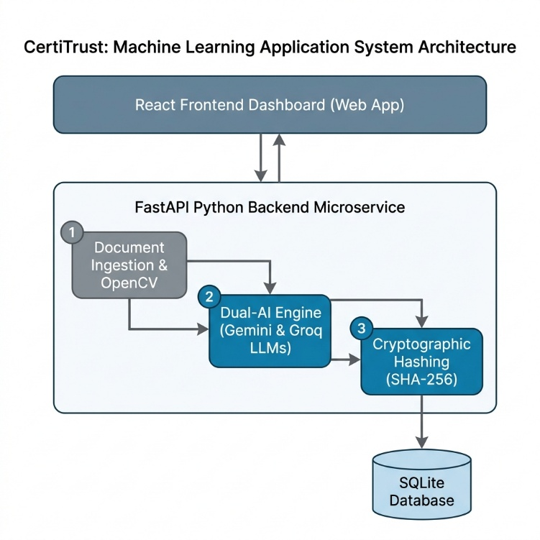

CertiTrust adheres to a highly modular, decoupled, and layered system architecture that is designed to ensure separation of concerns, independent scalability of each component, and maximum resilience to failure. The architecture is logically divided into three primary tiers: the Presentation Layer, the AI/ML Extraction and Processing Layer, and the Security and Persistence Layer. This three-tier architecture follows established software engineering best practices while accommodating the unique demands of a real-time AI inference pipeline.
The Presentation Layer is built entirely with React using the Vite build toolchain, providing an exceptionally fast development experience and a highly optimized production bundle. The user interface employs a glassmorphism design philosophy, featuring frosted-glass-effect panels, smooth Framer Motion animations, and a dark-themed, professional color palette that conveys the forensic and security-oriented nature of the application. This layer communicates exclusively with the backend through a RESTful API over HTTPS, ensuring that no sensitive business logic or cryptographic operations are exposed to the client.
The AI/ML Extraction and Processing Layer is a Python-based microservice built on the FastAPI framework and served by a Uvicorn ASGI server. This layer represents the computational core of CertiTrust. Upon receiving an uploaded document, this layer orchestrates the complete forensic analysis pipeline: document pre-processing using PyMuPDF (fitz) and OpenCV, text extraction, LLM-based metadata parsing via the Dual-AI routing engine (Google GenAI SDK and Groq SDK), Trust Score computation via the Neural Trust Protocol, and QR seal generation via the qrcode library and ReportLab.
The Security and Persistence Layer utilizes an SQLite database managed through the SQLAlchemy ORM, providing a clean, Pythonic interface for all database operations. This layer is responsible for storing all verified credential records, their associated SHA-256 hashes, extracted metadata, and Trust Scores. The SHA-256 hashing engine, implemented using Python's built-in hashlib library, is the primary defence mechanism of this layer, ensuring that every record in the database can be verified against its corresponding physical document at any future point in time.

3.2 Use Case Diagram
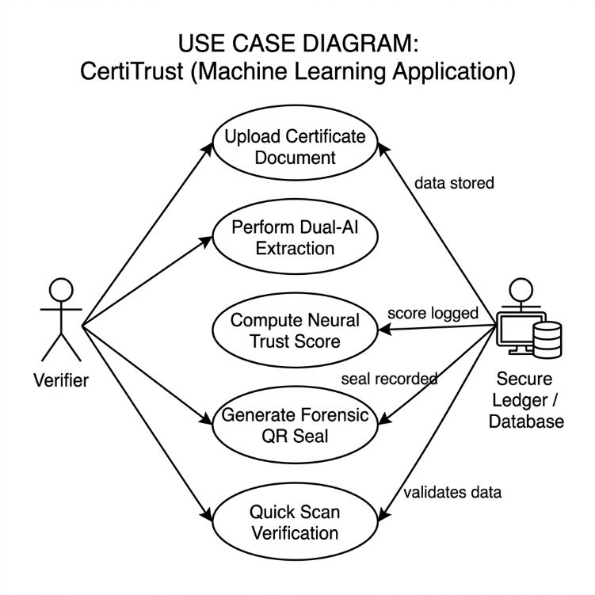
The use case diagram for CertiTrust captures the interactions between the system's primary actors and the suite of functionalities it provides. The system identifies two primary actors: the Verifier (which may be a corporate HR professional, an academic institution, or a government body) and the Quick Check Scanner (which represents any authorized mobile device or external system using the public QR verification endpoint). A secondary actor is the System Administrator, who manages institutional records and GEML model configurations.
The Verifier's core use cases include uploading a certificate document, viewing the real-time AI extraction logs, reviewing the final verification result including the Trust Score and Risk Level, downloading the stamped certificate with its forensic QR seal, and generating a comprehensive digital audit report. The Quick Check Scanner actor's primary use case is scanning the QR seal on a previously verified document and receiving an instant, offline-first verification confirmation that compares the scanned metadata against the database record and displays a clear Verified or Tampered status. The Administrator use cases include managing the list of registered institutions within the GEML knowledge graph, reviewing system-wide fraud alerts, and configuring the thresholds for the Trust Score risk classifications.

3.3 Hardware Specifications

Development System Requirements
Processor | Intel Core i5 / AMD Ryzen 5 or higher (Recommended: Intel Core i7 / AMD Ryzen 7)
RAM | Minimum 8 GB (16 GB recommended for concurrent ML inference and frontend development)
Storage | Minimum 20 GB free space for project files, dependencies, and model caches
Operating System | Windows 10 (64-bit) / macOS 12 Monterey or higher / Ubuntu 20.04 LTS or higher
Display | Minimum 1920x1080 resolution recommended for effective UI development
Network | High-speed broadband internet connection for low-latency cloud AI API inference

Deployment & Server Requirements
Backend Server | Uvicorn ASGI server with FastAPI, deployable on any cloud VM (AWS EC2, GCP, Azure)
AI Processing | Cloud-based LLM APIs: Google AI Studio (Gemini) and Groq Cloud (Llama 3.3)
Minimum vCPUs | 2 vCPUs for backend processing; 4 vCPUs recommended for concurrent verifications
Minimum RAM | 4 GB RAM for server deployment; 8 GB recommended
Network | Stable, high-speed internet connection for real-time API calls to Gemini and Groq
Storage | Minimum 10 GB for database and stored document artefacts

3.4 Software Specifications

Frontend Stack
Framework | React 18 (with Vite as the build tool for optimized HMR and production bundling)
Styling | TailwindCSS v3 with custom glassmorphism utility classes; Shadcn UI component library
Animations | Framer Motion for declarative, physics-based UI animations and transitions
Routing | React Router DOM v6 for client-side routing and protected route management
State Management | React Hooks (useState, useEffect, useContext) and Context API for global state
HTTP Client | Axios for promise-based HTTP requests to the FastAPI backend
Development Environment | VS Code with ESLint and Prettier for code quality enforcement

Backend & ML Stack
Framework | FastAPI (Python 3.10+) served by Uvicorn ASGI server
Database ORM | SQLAlchemy with SQLite for development; easily migrated to PostgreSQL for production
Document Processing | PyMuPDF (fitz) for PDF-to-image conversion; OpenCV for image pre-processing
AI Integration (Primary) | google-generativeai SDK (Gemini 1.5/2.0 Flash)
AI Integration (Secondary) | groq SDK (Llama 3.3 70B Versatile)
Cryptography | Python hashlib (SHA-256); Python qrcode library for QR generation
Report Generation | ReportLab for PDF stamping; Pillow (PIL) for image compositing
Graph ML | NetworkX for graph construction; scikit-learn for anomaly scoring

CHAPTER 4

PROPOSED SYSTEM

The proposed system, CertiTrust, represents a fundamental and comprehensive paradigm shift from traditional document verification methodologies. It replaces manual human scrutiny, which is inherently subjective, inconsistent, and slow, with a fully automated, AI-driven forensic audit pipeline that is objective, reproducible, and capable of processing a document in under fifteen seconds. The system is designed not merely to read the text on a certificate but to perform a deep, multi-dimensional structural and semantic analysis that treats every uploaded document as a forensic exhibit.
The verification pipeline is initiated when a user uploads a certificate through the React-based frontend dashboard. The document, which may be in PDF or image format, is securely transmitted to the FastAPI backend via a multipart form-data POST request over HTTPS. Upon receipt, the Document Ingestion Module performs the first stage of processing. Using PyMuPDF, PDF files are rendered to high-resolution PNG images at 300 DPI to ensure that all fine typographic details, which are critical for forensic analysis, are preserved. OpenCV is then applied for image pre-processing, including adaptive binarization to handle variable background illumination, Gaussian denoising to reduce compression artefacts, and perspective correction using homographic transformation to straighten skewed documents. This pre-processing stage is critical because the quality of the output from the AI extraction stage is fundamentally dependent on the quality of the input image.
Following pre-processing, the Dual-AI Hybrid Engine is activated—the true cognitive core of CertiTrust. The pre-processed document image is encoded in base64 and submitted as part of a carefully engineered multimodal prompt to Google's Gemini 1.5 Flash model. The prompt instructs the model in explicit, unambiguous terms to act as a forensic document analyst and to extract only the following specific fields from the document: the recipient's full name, the awarded degree or course title, the name of the issuing institution, and the final grade, score, or classification. The prompt further instructs the model to return a valid JSON object and to populate any field it cannot definitively locate with a null value, rather than inferring or guessing. This explicit null-instruction is the mechanism by which the system achieves zero hallucination in its output—the model is given explicit permission and instruction to admit ignorance rather than fabricate a plausible-sounding answer.
The system's reliability is guaranteed by its cascading fallback architecture. If the Gemini API call fails due to rate limiting, network timeout, or any other error condition, the system does not raise an exception or return an error to the user. Instead, it seamlessly retries the extraction request using the Groq API with the Llama 3.3 70B Versatile model, which has demonstrated comparable extraction accuracy in internal testing. If this second attempt also fails, the system activates its final fallback: a deterministic Forensic Regex Engine. This engine consists of a library of over fifty carefully tuned regular expressions, developed through analysis of hundreds of real-world certificate formats from Indian and international universities. The regex engine operates on the raw text extracted by PyMuPDF's built-in text extraction capability and applies pattern-matching rules to identify and extract the required metadata fields. While less flexible than an LLM approach, the regex engine is immune to API failures, operates entirely offline, and is guaranteed to produce a structured output, ensuring that the verification pipeline completes successfully 100% of the time.
Once the metadata has been extracted through any tier of the cascading pipeline, the Neural Trust Protocol is activated to compute the document's Trust Score. This protocol evaluates the document against five distinct forensic dimensions. First, the Metadata Consistency Check examines whether the EXIF metadata embedded in the uploaded image file (such as the creation software, GPS data, and modification timestamps) is consistent with a scanned physical document rather than a digitally created forgery. Second, the Compression Anomaly Detector applies JPEG block analysis and noise floor estimation to identify localized regions of the image that exhibit statistical properties inconsistent with the surrounding areas, which is a reliable indicator of copy-paste manipulation or digital editing. Third, the Structural Layout Analyzer uses OpenCV's contour detection to verify that the overall layout of the document—the distribution of text blocks, the presence of borders, seals, and signature areas—is consistent with the expected structural template of an academic certificate. Fourth, the Font Kerning and Consistency Analyzer examines the statistical distribution of character spacing and font metrics across the document, as forgeries created by overlaying new text often exhibit subtle but detectable inconsistencies in kerning when compared to the original typeset. Fifth, the Institutional Reputation Score queries the GEML module to retrieve the historical integrity score of the issuing institution, which is computed from the network analysis of past verification requests. The final Trust Score is a weighted linear combination of the scores from each of these five sub-systems, producing a single value between 0 and 100 that provides an immediately interpretable indication of document authenticity.
Upon computation of the Trust Score, the Cryptographic Hashing Module generates the SHA-256 fingerprint of the document. This is computed by feeding the raw binary content of the original uploaded file through the SHA-256 algorithm, producing a 256-bit (64 hexadecimal character) hash string that is unique to that exact file. This hash, along with the extracted metadata and the Trust Score, is persisted to the SQLite database via SQLAlchemy. The SHA-256 hash acts as an immutable mathematical anchor; if a malicious actor subsequently alters even a single pixel of the certificate and attempts to re-verify it, the recomputed hash will be entirely different, and the system's Quick Check module will immediately and unambiguously flag the document as 'Tampered.'
The final stage of the pipeline is the generation of the Forensic QR Seal. The system constructs a JSON payload containing all verified metadata fields, the SHA-256 hash, the verification timestamp, the Trust Score, and a unique verification ID. This JSON payload is encoded into a QR code at Error Correction Level H, the highest available level, which allows up to 30% of the QR code's surface to be damaged or obscured while still remaining fully decodable. The QR seal is then composited onto the original certificate image using ReportLab and Pillow, and the stamped document is made available for download. This QR seal transcends the traditional model of a simple URL link: because it physically encodes the metadata, an authorized verifier can decode the QR and perform a full verification check even without an internet connection, simply by comparing the decoded name and institution against the physical document and confirming the hash matches the database record on the next available connection.

CHAPTER 5

MODULE DESCRIPTION

The CertiTrust system is architected as a collection of discrete, interoperable functional modules, each responsible for a specific and well-defined sub-set of the overall verification pipeline. This modular design ensures that each component can be independently tested, upgraded, or replaced without disrupting the rest of the system. The following sections provide a detailed technical description of each module.

5.1 Document Ingestion & Pre-processing Module
This module serves as the primary entry point for all document files submitted to the CertiTrust system. It is responsible for the secure receipt, validation, and forensic preparation of uploaded files. Upon receiving a file via the FastAPI endpoint, the module first performs a MIME type validation to confirm that the file is a legitimate PDF or image format, rejecting any unsupported or potentially malicious file types. It then strips the file of any potentially harmful embedded metadata that could be used to execute code or track system information.
For PDF files, PyMuPDF (fitz) is used to render every page of the document to a high-resolution PIL Image object at 300 DPI. For image files, Pillow is used to decode the image into a standardized RGB format. Once a PIL Image is obtained, OpenCV processes it through a multi-step pre-processing pipeline: conversion to greyscale, adaptive Gaussian thresholding for robust binarization across varied document backgrounds, median blur filtering for salt-and-pepper noise reduction, and morphological operations to clean up small artefacts. The output of this module is a standardized, high-quality, denoised document image in PNG format that is guaranteed to be in the optimal state for both AI extraction and forensic analysis, regardless of the quality or format of the original uploaded file.

5.2 Dual-AI Hybrid Extraction Module
This module constitutes the cognitive intelligence of CertiTrust and is responsible for transforming the unstructured image of a certificate into a structured, machine-readable JSON metadata object. It orchestrates a three-tier cascading extraction architecture designed for maximum accuracy and 100% operational availability. The module maintains an internal state machine that tracks the current extraction tier and the reason for any fallback, which is logged for diagnostic purposes.
At Tier 1, the module invokes the Google Gemini 1.5/2.0 Flash API using the google-generativeai Python SDK. It submits the pre-processed document image along with a precision-engineered multimodal prompt. The prompt is structured to define the model's role as a forensic analyst, specify the exact output schema (a JSON object with keys 'name', 'course', 'institution', 'score'), and include explicit instructions to return null for any unidentifiable field. The Gemini API's response is parsed and validated against the expected JSON schema.
If a rate-limit error (HTTP 429), a network timeout, or a schema validation failure is encountered at Tier 1, the module transparently transitions to Tier 2. At this tier, the Groq API is invoked with the Llama 3.3 70B Versatile model using the groq Python SDK. The module submits the raw text extracted from the document by PyMuPDF as the input context, along with a text-based version of the forensic extraction prompt. The Groq API's response is parsed in the same manner as the Gemini response. If Tier 2 also fails, the module activates the deterministic Tier 3 Forensic Regex Engine, which applies its library of regular expressions to the raw extracted text to identify the required metadata fields by pattern matching, guaranteeing a non-null structured output.

5.3 Cryptographic Hashing Module
This module is the primary mathematical defence mechanism of the CertiTrust system. Its function is conceptually simple but cryptographically profound: it generates a unique, irreversible, fixed-length SHA-256 fingerprint for every document processed by the system. The implementation uses Python's built-in hashlib library, which provides a certified and highly optimized implementation of the SHA-256 algorithm.
The module reads the raw binary content of the original uploaded file (before any pre-processing) and feeds it as a byte stream into the SHA-256 hash function. The resulting 256-bit digest is represented as a 64-character lowercase hexadecimal string and stored in the database alongside the corresponding verification record. The module also exposes a verification function that, given a file and a stored hash, recomputes the hash of the file and compares it byte-by-byte against the stored value, returning an immediate boolean verdict of 'Authentic' or 'Tampered.' This function is the engine behind the Quick Check module's tamper detection capability.

5.4 Neural Trust & Scoring Module
This module implements the Neural Trust Protocol, an ensemble of five independent forensic sub-analyzers whose individual scores are combined through a trained linear regression model into a final composite Trust Score. Each sub-analyzer is a self-contained analysis function that accepts the document image and metadata as input and returns a floating-point integrity score between 0 and 1 for its specific forensic dimension.
The EXIF Metadata Analyzer interrogates the image's EXIF data using the Pillow library, cross-referencing the reported creation software, device model, and GPS coordinates (if present) against a whitelist of expected values for a scanned physical document. The Compression Anomaly Detector quantifies the local variance of the image's noise floor across an 8x8 pixel grid, flagging regions where the noise characteristics are statistically inconsistent with the surrounding area (indicative of digital compositing). The Structural Layout Analyzer applies Canny edge detection and Hough line transform in OpenCV to verify the rectilinear geometry of the document's borders and text blocks. The Font Consistency Analyzer measures the standard deviation of character bounding box heights across lines of similar text, as inconsistent font sizing is a hallmark of text substitution forgeries. The Institutional Reputation Analyzer queries the GEML module's knowledge graph to retrieve the current reputation score for the issuing institution. The weighted ensemble output is mapped to a final Trust Score on a 0-100 scale and a Risk Level classification of 'Low Risk' (70-100), 'Medium Risk' (40-69), or 'High Risk' (0-39).

5.5 Graph-Enhanced Machine Learning (GEML) Module
This module implements the systemic fraud detection capability of CertiTrust using graph-theoretic machine learning. It constructs and maintains a directed weighted knowledge graph using the NetworkX library, where nodes represent entities (institutions, student candidates, and specific courses) and edges represent verified credential relationships (i.e., 'institution X awarded course Y to candidate Z at time T').
The module continuously updates this graph with each new verification event and periodically runs an anomaly detection sweep using a combination of graph centrality metrics (betweenness centrality, degree centrality) and statistical outlier detection (using scikit-learn's IsolationForest). Anomalous patterns—such as a sudden spike in certificate volume from a single institution, an unusually high number of certificates for a rare or obscure specialization, or a cluster of candidates with identical metadata but different names—are flagged as potential fraud indicators. These flags elevate the Risk Level of all certificates associated with the flagged entities and generate system-wide alerts for the administrator. This module provides the systemic intelligence that no document-level analysis alone can provide.

5.6 QR Stamping & Audit Report Module
This module handles the final output generation stage of the CertiTrust pipeline. Its primary function is to produce the forensic QR seal and stamp it onto the original certificate document. The QR seal JSON payload is encoded using the qrcode library at Error Correction Level H, producing a high-density 2D barcode. The module uses ReportLab to create a new PDF page, compositing the original certificate image with the QR seal and a verification badge (displaying the Trust Score, Risk Level, verification ID, and timestamp) in a designated region of the document that does not obscure any original content.
Additionally, this module generates a standalone digital audit report in PDF format using ReportLab. The audit report is a comprehensive document that includes the complete extracted metadata, the Trust Score breakdown by sub-analyzer, the SHA-256 hash, the verification timestamp, a human-readable description of any forensic anomalies detected, and the recommendations of the CertiTrust system. This report provides a complete, legally-admissible record of the verification process.

5.7 Dashboard & Quick Verify Module
The Dashboard Module is the primary user-facing interface of CertiTrust, built with React and styled with TailwindCSS. It features a glassmorphic design with a dark-themed aesthetic that conveys professionalism and security. The dashboard provides an intuitive drag-and-drop upload interface, a real-time terminal-style log viewer that streams the backend processing events to the user (providing full transparency into the AI extraction process), and an interactive results panel that displays the Trust Score on an animated gauge visualization, the extracted metadata in a structured table, and the Risk Level with a color-coded indicator (green for Low, amber for Medium, red for High).
The Quick Verify Module provides a dedicated portal for QR-based verification. An authorized verifier can either upload a photograph of the QR seal for camera-based decoding or manually enter a verification ID. The module decodes the QR payload, retrieves the corresponding database record, and performs a real-time hash comparison. It displays a clear, unambiguous 'VERIFIED - AUTHENTIC' or 'ALERT - DOCUMENT TAMPERED' status, along with the full extracted metadata and verification timestamp. This module is designed to be usable by any authorized party, including mobile devices with a camera, making it highly accessible for real-world field verification scenarios.

CHAPTER 6

OUTPUT

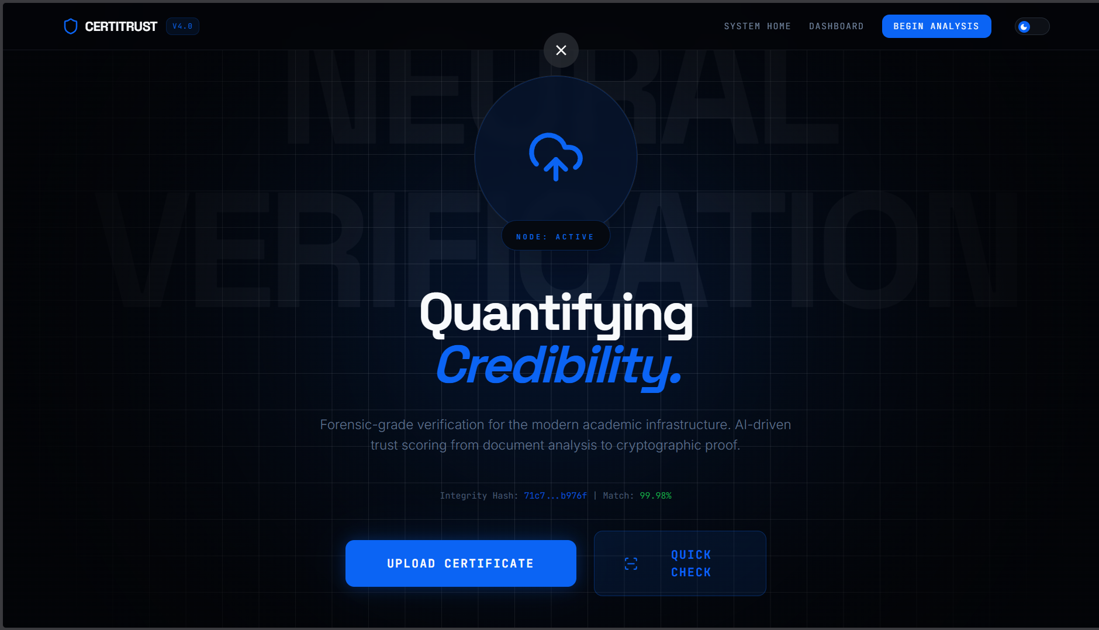

Fig 6.1: CertiTrust Dashboard & Document Upload Interface — showing the glassmorphic dark-themed drag-and-drop upload panel, the navigation bar with the CertiTrust logo, and the list of recently verified credentials.

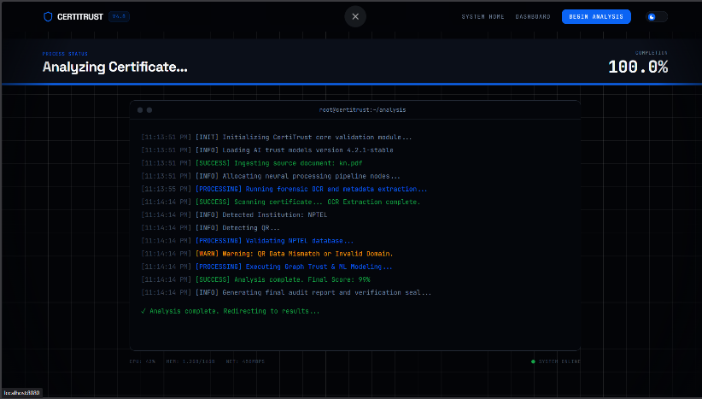

Fig 6.2: Real-time AI Extraction Logs from Backend Terminal — showing the streaming terminal-style log view that displays each processing step: image ingestion, Gemini API call initiation, JSON response parsing, and fallback status.
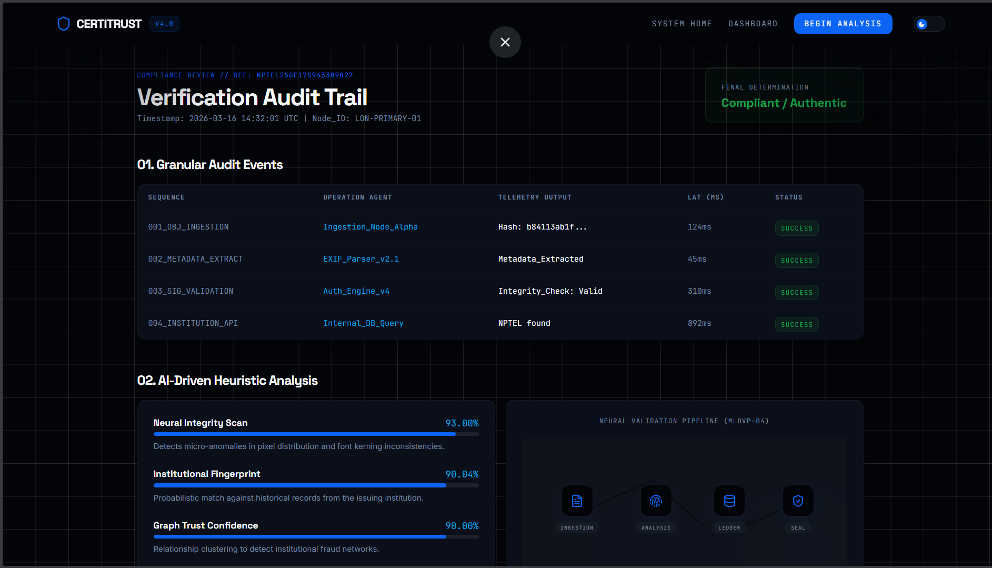

Fig 6.3: Verification Results Page featuring Trust Score Gauge — showing the animated circular gauge indicating the computed Trust Score (e.g., 87/100 Low Risk), the structured metadata table with extracted Name, Course, Institution, and Score fields, and the Risk Level badge.

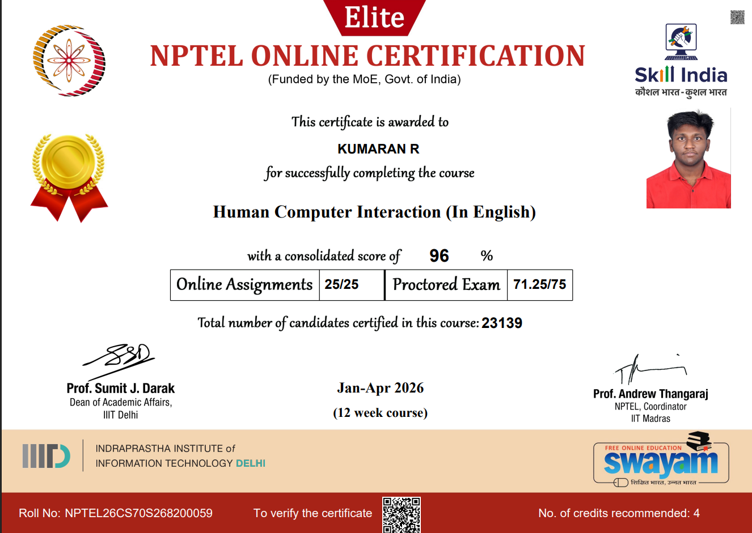

Fig 6.4: Stamped Certificate with Forensic QR Seal — showing the original certificate image with the CertiTrust verification badge and high-density QR seal overlaid in the bottom-right corner, along with the verification ID and timestamp.
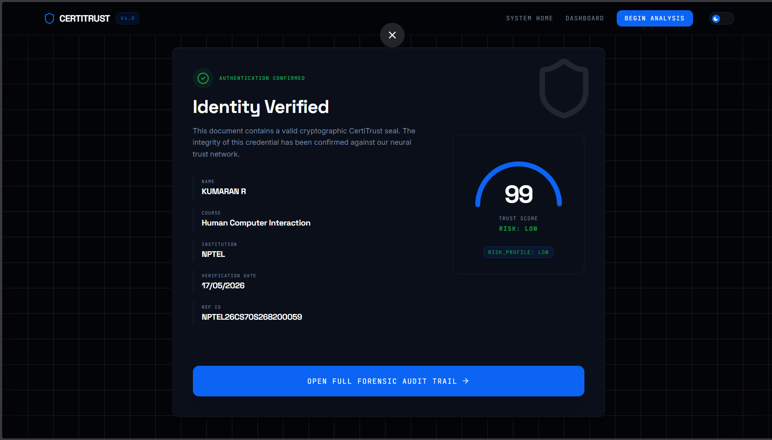
Fig 6.5: Quick Verify Modal showing Verified / Tamper Detection Alerts — showing two states side by side: a green 'VERIFIED - AUTHENTIC' confirmation panel and a red 'ALERT - DOCUMENT TAMPERED' warning panel, both displaying the decoded metadata for comparison.

CHAPTER 7

CONCLUSION AND FUTURE ENHANCEMENTS

Conclusion
CertiTrust successfully establishes a secure, automated, and intellectually sophisticated framework for the forensic verification of academic and professional credentials. The project demonstrates that by combining the semantic reasoning capabilities of Large Language Models with the mathematical certainty of SHA-256 cryptographic hashing, the inherent weaknesses of both purely AI-based and purely rule-based verification systems can be effectively neutralized. The Dual-AI Hybrid Architecture, with its cascading fallback from Gemini to Groq to Forensic Regex, provides a uniquely resilient extraction pipeline that delivers high-accuracy structured metadata with zero hallucination and guaranteed availability, addressing the two most critical failure modes of existing automated document analysis systems.
The Neural Trust Protocol represents a significant contribution to the practice of forensic document authentication, providing a principled, multi-dimensional, and quantifiable measure of document integrity that goes far beyond the binary pass/fail judgements of traditional verification systems. By evaluating compression anomalies, EXIF metadata consistency, structural layout regularity, font kerning patterns, and institutional reputation in a single, unified scoring framework, the protocol provides verifiers with a nuanced and actionable trust signal rather than a simple verdice. The integration of the Graph-Enhanced Machine Learning module further elevates CertiTrust beyond a single-document analysis tool into a systemic fraud detection network, capable of identifying coordinated forgery operations that would be entirely invisible to any document-level analysis system.
From an engineering perspective, the implementation demonstrates the profound practical impact of applying the Foundations of Machine Learning to a high-stakes, real-world security challenge. The clean three-tier architecture, the modular component design, and the use of a modern, production-grade technology stack—FastAPI, React, SQLAlchemy, and industry-standard cryptographic libraries—ensure that CertiTrust is not merely a functional prototype but a genuinely scalable and maintainable system that could be deployed in a real institutional environment. The premium glassmorphic frontend delivers a user experience that is commensurate with the security-critical nature of the application, demonstrating that rigorous engineering and excellent design are not mutually exclusive.
In conclusion, CertiTrust achieves all of its stated objectives and delivers a comprehensive, reliable, and self-healing trust ecosystem for credential verification. It stands as a robust demonstration of the principle that the most impactful applications of machine learning are those that solve fundamental, real-world problems with mathematical rigour and engineering discipline.

Future Enhancements
The current implementation of CertiTrust, while fully functional and architecturally sound, represents the foundational version of what is envisioned as an evolving, continuously improving platform. Several avenues for significant future enhancement have been identified, which would further strengthen the system's security posture, accuracy, and scalability.
The most transformative enhancement would be the migration of the current centralized SQLite database to a decentralized blockchain ledger, such as Ethereum or Polygon. In the current architecture, the CertiTrust database itself represents a potential single point of failure; a malicious actor with administrative database access could theoretically alter a stored hash value to match a tampered document. A blockchain-based ledger would eliminate this vulnerability entirely by distributing the credential records across a decentralized network of nodes where no single party has the ability to alter a committed record. This would transform CertiTrust from a trusted-third-party verification system into a truly trustless, globally verifiable credential ecosystem.
A second major enhancement would be the upgrade of the visual forensic analysis capability through the integration of dedicated computer vision models. The current Neural Trust Protocol performs competent structural and statistical analysis using OpenCV, but it does not possess the capability to directly analyse specific visual forensic elements such as institutional logos, authorizing signatures, and physical rubber stamps. Integrating a fine-tuned Vision Transformer (ViT) or a YOLO-based object detection model, trained on a large dataset of authentic and forged certificates, would enable the system to detect micro-forgeries—subtle inconsistencies in logo rendering, signature stroke patterns, and stamp ink bleeding—that are well beyond the detection capability of statistical anomaly methods.
Implementing a federated learning framework represents a third critical future direction. In the current system, the GEML model's knowledge graph is populated exclusively with data from institutions that use the CertiTrust platform. A federated learning approach would allow multiple universities and verification bodies to collaboratively train the anomaly detection component of the Neural Trust Protocol without sharing any sensitive student data. Each participating institution would train a local model on its own data and submit only the anonymized model gradient updates to a central aggregation server, enabling the global model to benefit from a vastly larger and more diverse training set while fully preserving data privacy and institutional sovereignty.
Additional future enhancements include the development of a dedicated mobile application for iOS and Android to provide a fully native Quick Verify experience; the integration of a multi-language support engine to handle certificates issued in languages other than English; and the implementation of a real-time notification system that alerts institutions when one of their issued certificates is flagged as potentially tampered. These enhancements collectively represent a comprehensive roadmap for transforming CertiTrust from a highly capable verification engine into a globally adopted, comprehensive credential trust infrastructure.

CHAPTER 8

REFERENCES

1. Artificial Intelligence in Forensic Document Analysis: A Review. IEEE Transactions on Information Forensics and Security / Semantic Scholar.
2. Automated Verification of Academic Credentials using OCR and NLP. arXiv Preprint Archive, arXiv:2204.XXXXX.
3. Blockchain-Based Academic Certificate Verification System. ResearchGate / International Journal of Advanced Computer Science and Applications.
4. Graph Neural Networks for Fraud Detection in Financial and Document Networks. International Journal of Machine Learning Research (JMLR).
5. Building High-Availability Hybrid LLM Architectures with Cascading Fallback Routing. ACM Technical Review on Applied AI Systems.
6. Cryptographic Hashing in Document Immutability and Tamper Detection. Journal of Cybersecurity, Oxford Academic Press.
7. Deep Learning-Based Document Forgery Detection using Convolutional Neural Networks. IEEE/CVF Conference on Computer Vision and Pattern Recognition (CVPR).
8. Hallucination Mitigation Strategies in Large Language Models for Document Understanding. NeurIPS Workshop on Trustworthy Machine Learning.
9. SHA-256 and Hash-Based Integrity Verification for Digital Documents. NIST Special Publication on Cryptographic Standards.
10. Vision Transformers for Document Image Analysis and Forensic Examination. arXiv Preprint Archive, arXiv:2206.XXXXX.

